Supplementary Information

Contents
I. Preparation of Micro-Droplet System
II. Photon-Counting System
III. Efficiency of ATP Detection
IV. Number of ATP Molecules Synthesized per Turn
V. Effect of Phosphate and ADP on the Luminescence Kinetics of Luciferase
VI. Background ATP Level

I. Preparation of Micro-Droplet System
We functionalized a 32×24 mm² coverglass, pre-cleaned with KOH, with a silane coupling agent having an –SH group (TSL 8380, GE Toshiba Silicone) and reduced the –SH groups with 50 mM DTT. Then we applied, using a glass micropipette, 10 mg ml⁻¹ maleimide-C₃-NTA (Dojindo) to a surface such that a droplet of diameter ∼10 μm and height <2 μm was formed. After making 4×4 droplets separated by ∼50 μm (Fig. S1) and waiting for 5-10 min in a humid atmosphere, we rinsed the coverglass with water. We then applied 10 mM NiCl₂ to the treated surface to form 4×4 dots coated with Ni-NTA. After 10 min, we extensively washed the coverglass with water and dried it. We placed a silicone-rubber frame on the coverglass to form a rectangular well, and filled it with mineral oil (Sigma) which had been bubbled with water-saturated oxygen (Fig. S1). Using a micropipette, we applied 2.6 pM F₁ in buffer B (10 mM Tris, 15 mM K₂SO₄, 2 mM MgSO₄, pH 8.0) to each Ni-NTA dots, where a micro droplet stayed stably under oil, thanks to the hydrophilic nature of the Ni-NTA surface. After 10 min, we removed unbound F₁ by flushing the droplet with buffer B₆ (buffer B plus 6 mg ml⁻¹ BSA), using infusion and suction micropipettes. We then added ~0.5 pM magnetic beads coated with streptavidin in buffer B₆ to the droplet and waited for 20 min. Unbound beads were removed by flushing with buffer B₆. Finally, we replaced the droplet medium with buffer B containing 3 mg ml⁻¹ BSA, 5 μM luciferase, 1 mM luciferin, 3 mM K₂PO₄ (pH 7.5) and 100 μM ADP. At this stage, typical droplet size was 30 μm wide (BSA widened the hydrophilic spot) and 3 μm high; with time, droplets tended to flatten and shrink in volume.
The image in Fig. S1, lower right, shows photons detected over a 5-min interval during the synthesis experiment. Droplets were identified in a transmitted image, shown on the left, acquired after the experiment. Photons within a droplet periphery identified by eye (image on lower left) were counted. Photons in one area outside droplets (bottom of the image on lower left) were also counted to estimate the background level.
Figure S1. Demonstration of ATP synthesis in micro droplets.

II. Photon-Counting System
The photon-counting camera that we used is made of an image intensifier (V8070U-64-N230, Hamamatsu Photonics) connected to a CCD camera (C2400-77, Hamamatsu) via a tapered optical fibre and housed in a cooling box at -16 °C (C4566, Hamamatsu). The image of an incident photon is blurred by the intensifier and occupies, typically, 4-5 pixels of the CCD camera; most electrical noises produce a similar point image, but noise due to intra-tube ionization produces a much more intense and wide image. A built-in electronic circuit calculates the centroid of these images and registers one count at the centroid position; even the large ionization noise is reduced to one count. The overall detection efficiency is such that one in about ten incident photons produces one count in the final image (quantum efficiency of the GaAsP photo-cathode is about 40%, but some loss of photoelectrons and the fibre coupling reduce the overall efficiency to ∼10%). In the complete darkness, electrical noise in the camera produced 15 counts per second over the whole imaging area of 512×480 pixels. In the experiment shown in Fig. 3 in the main text, we counted photons from a circular area of a sample (7.8×10⁴ μm²), which was projected onto a circle of diameter ∼310 pixels on the camera. The dark counts in the circle amounted to ∼5 counts per second or 1.5×10³ counts per 5 min, lower than the count due to the background luminescence from the ADP-luciferase solution.

III. Efficiency of ATP Detection
To estimate the overall efficiency of ATP detection, we put a 3-mm thick silicone rubber sheet, having a 5-mm hole at the centre, on a coverglass and placed it on the microscope stage. 20 μl of the luciferase solution without beads and F₁ (buffer A containing 10 μM luciferase, 1 mM luciferin, 10 mM K₂PO₄, 200 μM ADP, and 1.5 mg ml⁻¹ BSA) was placed in the hole. In the complete darkness, 2 μl of a known concentration of ATP was mixed with a pipette and the luminescence flash was monitored with the photon-counting camera (Fig. S2). Over the ATP concentrations of 0.2-2.4 nM, the flash could be approximated by the sum of two exponential decays, one with a time constant of 27±10 s and amplitude 66±15 % and the other 2.9±1.1 min and 34±15 % (11 measurements). The integrated counts over 800 s, excluding the final constant level which constitutes the background luminescence, were proportional to the ATP concentration (Fig. S2, inset) and amounted to 0.009±0.001 detected photons per ATP molecule. Here, the number of ATP molecules contributing to the luminescence was calculated as [image area = 1.0×10⁴ μm² corresponding to 100×100 pixels on the camera]×[solution height = 1.1 mm]×[ATP concentration], because molecules at different heights h from the focal plane contribute equally to an image pixel: brightness per molecule is proportional to h⁻² and the number of contributing molecules to h². Varying the sample volume in the hole, and thus height (0.25-1.25 mm), verified that the intensity was proportional to the sample height.
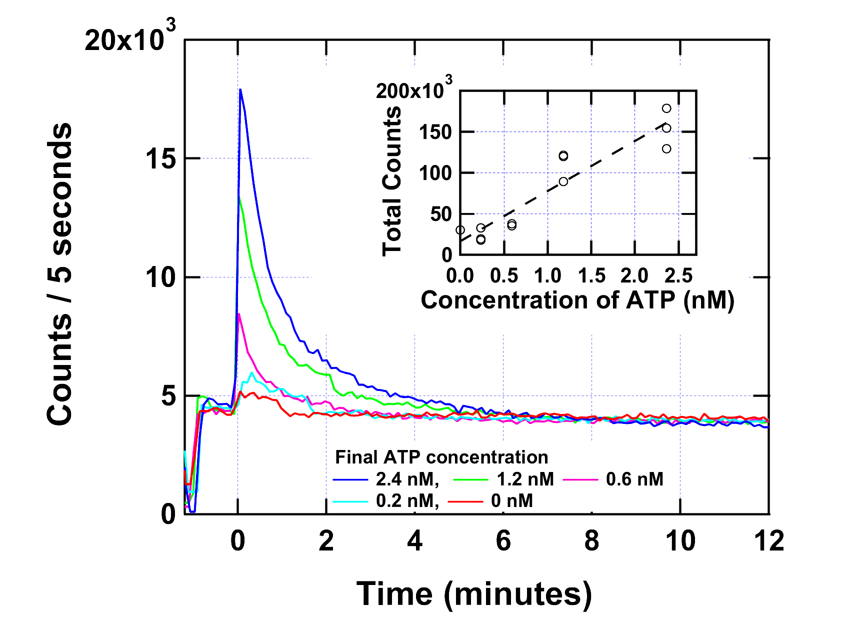
Figure S2. Luminescence flash at various ATP concentrations. The ordinate shows the total number of photons detected over 100×100 pixels on the camera per 5-s exposure time. At about -1 min, a shutter before the camera was closed to bring the pipette tip just above the solution in the chamber. After opening the shutter, ATP was mixed with the pipette at time 0. To aid comparison, the curves are slightly shifted vertically, within 1×10³ counts, so that the background levels before mixing appear the same. Inset shows the integrated counts, above the final constant level, for 11 measurements (some symbols overlap with another). Linear regression line has a slope of 6.1×10⁴ integrated photons per 100×100 pixels per nM ATP.

IV. Number of ATP Molecules Synthesized per Turn
In the experiments with a flat chamber (Figs. 3 and 4 in the main text), there were, on average, 480 F₁ molecules on the bottom and 100 F₁ molecules on the ceiling in the field of view of 1.0×10⁵ μm². When the beads were rotated clockwise, F₁ on the bottom would synthesise ATP while F₁ on the ceiling would rotate in the hydrolysis direction. Below we neglect the possible consumption of newly synthesized ATP by F₁ on the ceiling, because most of ATP synthesised on the bottom would be captured by 10 μM luciferase in the solution and because hydrolysis (but not synthesis) of ATP by F₁ tends to be inhibited by MgADP in the medium. We also neglect possible diffusional escape of newly synthesised ATP toward periphery of the observation chamber (18×18 mm²), because the electromagnets (tip separation ∼5 mm) generated torque over the central area of ∼10 mm in diameter and diffusion of ATP over 5 mm would take hours.
The data in Fig. 4 in the main text shows that 6,500 photons were detected during 5 min of clockwise rotation at 3 Hz. This amounts, according to the detection efficiency of 0.009 photon per ATP above, to the synthesis of 2,400 ATP molecules s⁻¹ in the image area or 5 ATP molecules s⁻¹ per F₁. The last number is to be compared with 9 ATP molecules s⁻¹ expected at 3 Hz for 100% coupling efficiency.
For the data in Fig. 3a in the main text, there are seven curves for which 12 measurements were made including the last (third) no-rotation data. For these, the difference between the average counts in clockwise and no rotation (S-N) is 2,500 counts per 5 min or 930 ATP molecules s⁻¹. This number is for the imaging area of 7.8×10⁴ μm² where 370 F₁ molecules would rotate at the bottom. The synthesis rate is thus 2.5 ATP s⁻¹ per F₁ at bottom for clockwise rotation, which is considerably lower than the expected rate of 30 ATP s⁻¹ for 10 Hz rotation. One reason is that 10 Hz was too fast, as seen in Fig. 4b in the main text, another the large chamber to chamber variation, a third the carry-over of ATP-induced luminescence to the next 5-min period due to slow reaction of luciferase (see below). The apparent rate of synthesis during anticlockwise rotation (H), due to F₁ on the ceiling, is higher than the rate during clockwise rotation (S), but this is also accounted for by the carry-over effect (the sequence was such that H always followed S except for the first H).

V. Effect of Phosphate and ADP on the Luminescence Kinetics of Luciferase
In Fig. 3b in the main text, we report that the luminescence background from luciferase-ADP solution without phosphate was considerably lower than that in the presence of phosphate. Here we show kinetic data possibly explaining this behaviour. Measurements were made as in III, except that phosphate was removed from the solution. As seen in Fig. S3, phosphate adds a slow component to the ATP-induced luminescence flash.
Without ADP, luminescence decayed exponentially to a low level (Fig. S3), suggesting that the long-lasting background luminescence was due to ADP (also see VI below). The integrated photon counts above the background level are within ±10% of each other among the three conditions, implying that the photon/ATP ratio estimated in III above is valid whether ADP and Pi are absent or not.
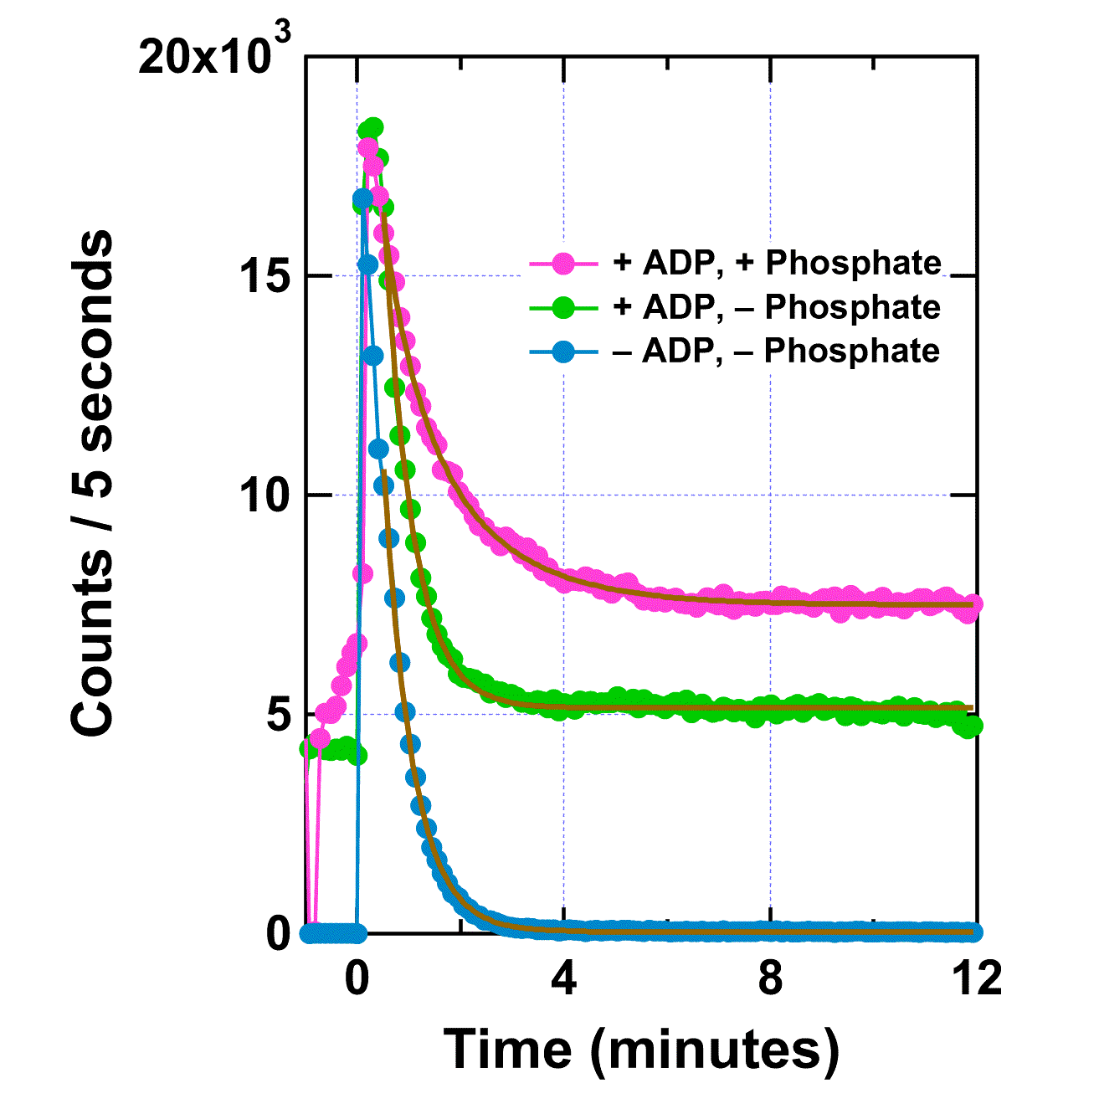
Figure S3. Effects of phosphate and ADP on luminescence flash. Experiments similar to Fig. S2. At time 0, 1.8 nM ATP (final concentration) was mixed with the luciferase solution with 200 μM ADP and 10 mM phosphate (magenta), with 200 μM ADP and without phosphate (green), or without ADP and without phosphate (cyan). Gold lines show exponential fit: 7100exp(-t/0.64) + 7600exp(-t/1.62) + 7500 for +ADP/+phosphate; 28700exp(-t/0.55) + 5100 for +ADP/-phosphate; 26400exp(-t/0.56) + 45 for –ADP/-phosphate.

VI. Background ATP Level
In Fig. S2, the peak intensities represent the luminescence levels before the added ATP was consumed by luciferase. The peak height would be twice the background level at an added ATP concentration between 0.6 and 1.2 nM, indicating that the background ATP level was about 1 nM in our experiments. Somehow, this much of ATP remained in the solution even after the luminescence due to added ATP had decayed; the background luminescence did not decrease appreciably when the solution was left overnight. The background luminescence was practically negligible in the absence of ADP (Fig. S3). We suspect that our samples were contaminated by adenylate kinase, which produces ATP (and AMP) from 2ADP: a steady-state ATP level would be reached when ATP production by adenylate kinase and ATP consumption by luciferase balance. As shown in Fig. S4, as little as a few pM of adenylate kinase can explain our background level. We tried to obtain direct proof of contamination by adenylate kinase by adding Ap5A which is a specific inhibitor of adenylate kinase. However, Ap5A somehow induced strong and sustaining luminescence, preventing any meaningful measurement.
Although we could not identify the source of the background luminescence unambiguously, the steady level of ∼1 nM ATP in our samples has an important consequence. That is, the mechanically-driven ATP synthesis was made under the condition where free-energy balance strongly favoured hydrolysis. The free energy for ATP hydrolysis is given by
ΔG = ΔG₀ + k_{B}Tln[ADP][phosphate]/[ATP]
where ΔG₀ = -58 pN nm (extrapolated to the value at pH 7.6 from ref. 9 in the main text) and k_{B}T = 4.1 pN nm is the thermal energy at room temperature. For our experiments at [ADP] = 200 μM, [phosphate] = 10 mM, and [ATP] = 1 nM, ΔG is -28 pN nm, the negative sign implying that the equilibrium is on the side of hydrolysis. Thus, the ATP synthesis in our experiments was uphill, requiring 28 pN nm of energy input.
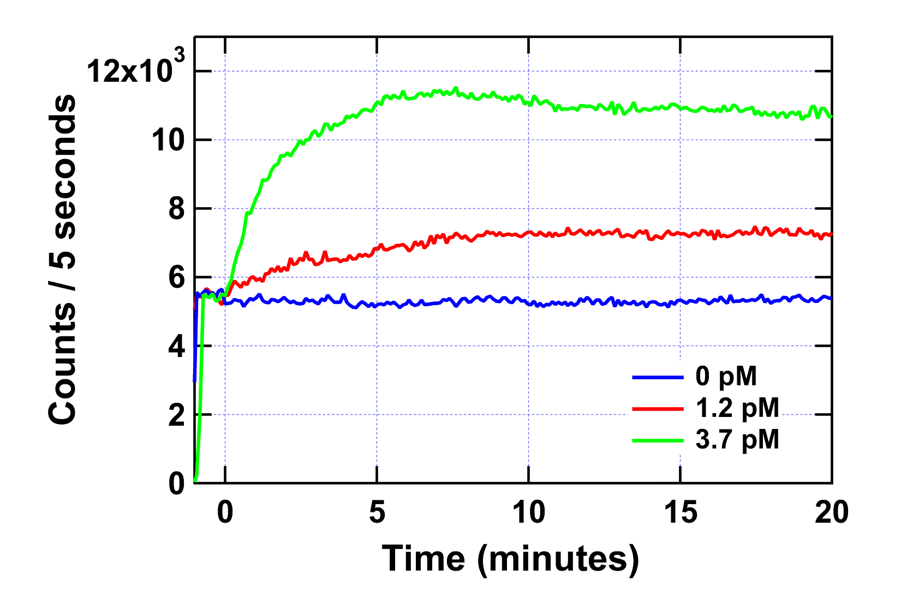

Figure S4. Effect of adenylate kinase on the luminescence level. At time 0, indicated concentrations (final) of adenylate kinase (rabbit muscle, Sigma) was added. Other conditions were as in Fig. S2.

